IPC1_Tarea 2
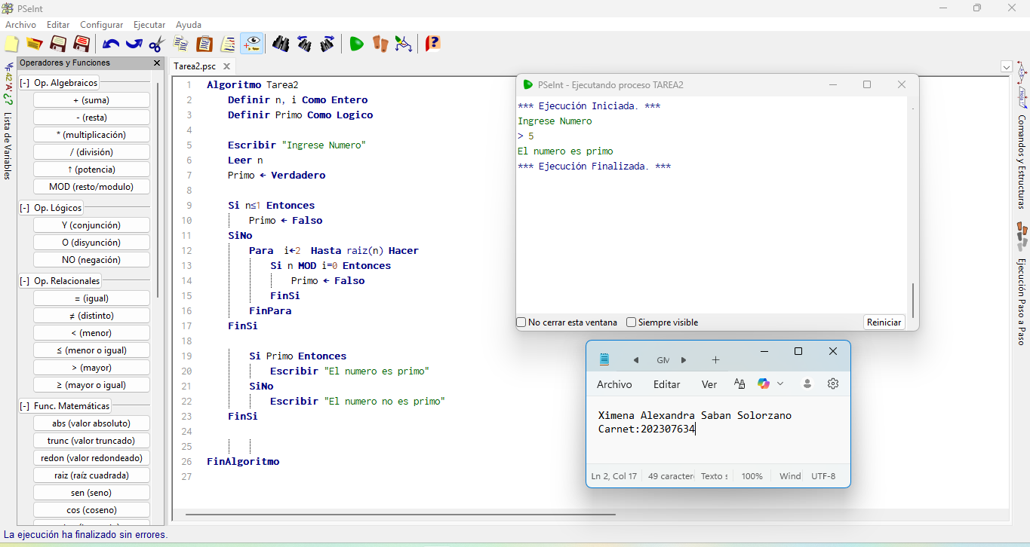
Ximena Sabán – 202307634

